Recommendations for Big Mountain Resort

After performing some through analyses using ski resort data from resorts all over the united states, we believe that Big Mountain Resort should (1) rise their ticket prices to $86 per adult, (2) consider adding an additional chair lift to enable further runs throughout the park and (3) monitor semi-annually what are some of the offerings and pricing that competing resorts within Montana and across the US use to ensure Big Mountain does not find itself priced out of the market.

Seeing Figure 1, you can appreciate that the distribution of ticket prices is positively skewed, with the majority of resorts being on the right side of the mode. With that said, Big Mountain’s ticket price is above average yet not seen as an outlier within this dataset, which suggests room for a price increase. However, putting this data in the context of the state in which Big Mountain is found (Montana) – Figure 2- we see a slightly different story. Big Mountain is the only park in the whole state that charges over $70 per ticket, which implies that their current price is well above their high given their competitors’.

That being said, the predicted ticket price we estimated using our regression model – Figure 3 – indicates Big Mountain’s ticket is underpriced, since the predicted ticket price for Big Mountain is close to $96 while its current price is $81. Additionally, considering the mean absolute error is around $10 we believe that a price increase that pushes Big Mountain’s ticket price to the lowest possible price subject to the mean absolute error’s bound would reflect a sober decision on management’s end.

On a separate note, as it relates to projects the resort should invest in, we firmly believe that adding additional chair lifts to increase the vertical drop by adding a run to a point that is 150 feet lower down would have a strong positive economic impact in the resort’s revenue numbers. This is something we found using our regression model, which indicated that this resort enhancement would imply a ticket price increase of $8.61 per ticket or in relative terms at 10% price increase. Understandably, before embarking on an expansion of this nature, it would be prudent to understand what would be the budgetary constraint and the return on investment horizon for the project.

As a final recommendation, we strongly suggest Big Mountain resort reruns these models every half year (if the data permits it), since these statistics and models would need to be recalibrated based on the changes in pricing, runs, skiable area, etc. that other resorts would offer in the future. Additionally, if any substantial changes or modifications to the park were to be implemented, we would encourage Big Mountain to run a pre- and post-modification impact on ticket pricing to ensure that resources are being allocated towards the modifications that would have the best return on investment.

Figure 1. Adult weekend ticket price ($) distribution for resorts in market share

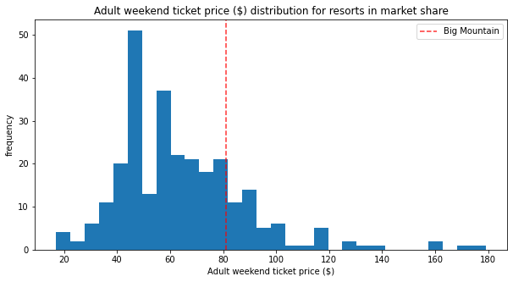

Figure 2. Adult weekend ticket price ($) - Montana only distribution for resorts in market share

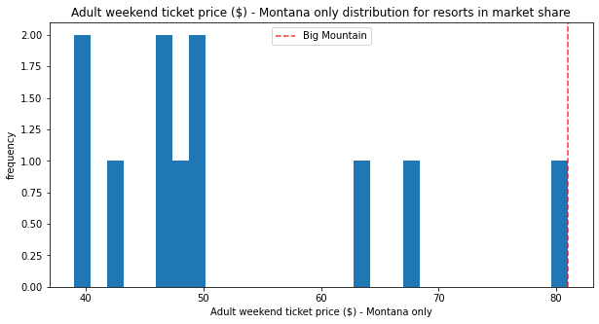

Figure 3. Excerpt from Ski Resort Data Study.

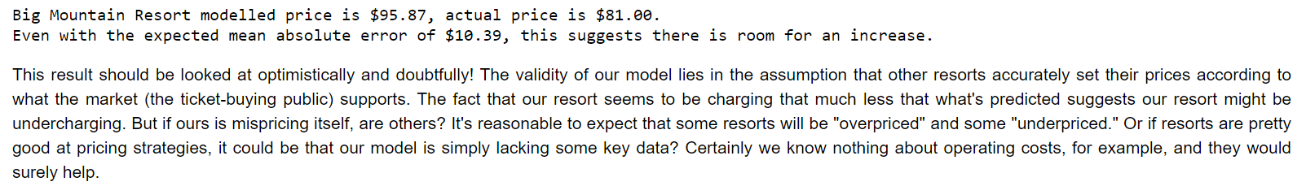

Figure 4. Excerpt from Ski Resort Data Study Scenario Analysis

